
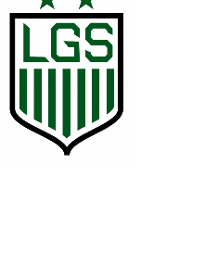
Allegany-Limestone Winter Classic

RELEASE: By enrolling the below-named child in this tournament, I certify that he/she is of normal health, and capable of safe participation in the tournament. I recognize that there are inherent dangers in sport, and I assume all risks and hazards incidental to this tournament. I authorize medical treatment for this player if he/she becomes injured, unless I am personally present to waive such treatment. I am responsible for any medical bills arising from such treatment. Allegany Soccer, Allegany-Limestone School District and its affiliates cannot accept the responsibility or liability for any injuries sustained during this tournament.
Team Name:_____________________________________________________ Team Color: __________________________________
8 player MAXIMUM for Saturday games 10 player MAXIMUM for Sunday games
Age Division: _______ 3rd/4th Girls _______3rd/4th Boys _______ 5th/6th Girls _______ 5th/6th Boys
________ 7th/8th Girls ________ 7th/8th Boys _______ 9th/10th Girls _______9th/10th Boys
Coach Name(s): _________________________________________________________ Cell #(s): ______________________________
Coach Email(s): ____________________________________________________________________________________________________
Roster/Waiver Release Form – One Form Per Team

ROSTER | 8 player MAXIMUM for Saturday games  10 player MAXIMUM for Sunday games
Player Name |  | DOB | Grade | Medical Conditions | Parent Name - Printed | Parent Signature
1
2.
3.
4.
5.
6.
7.
8.
9.
10.
Contacts:
Angela Honeck
Ahoneck7@hotmail.com
Jon Luce
jluce@alcsny.org

Mail check to:
Angela Honeck
837 Four Mile Road
Allegany, NY 14706

Registration Fee:
$150 Due by 1/14/26
Check - made payable to: ALCS Sports Boosters

