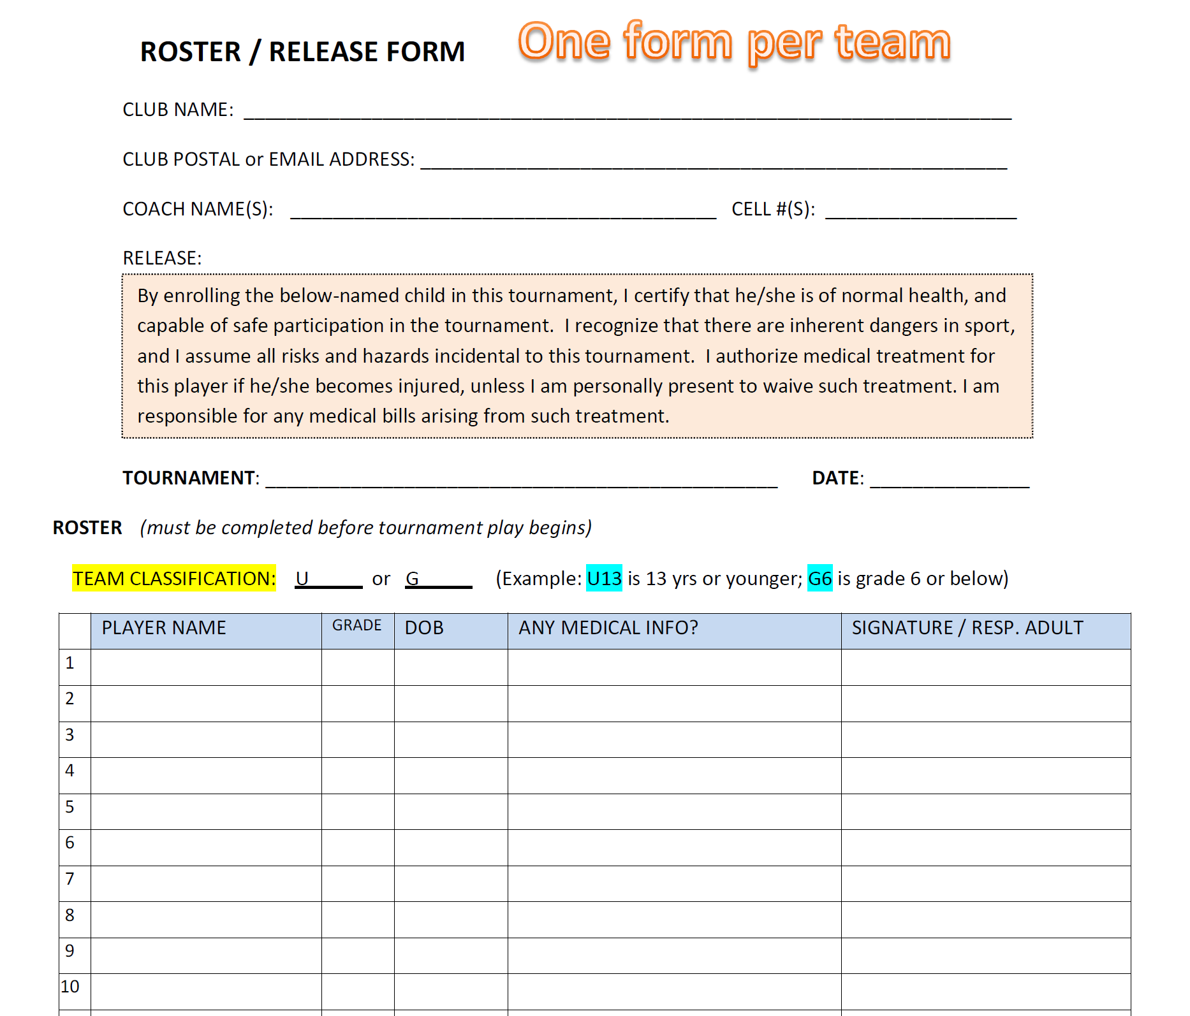

The Canisteo Greenwood Soccer Club has a 10-player roster limit for the tournaments. Players must be from the same School District.
Roster and fee may be brought to the tournament. Please confirm 2 weeks before the dates.
Fee for 2025 is $150 per team made payable to: CGSC

