2023 GANANDA INDOOR SOCCER TOURNAMENT

Dear Soccer Coach or Manager:

The Gananda Bandits will be hosting the 15th Annual Indoor Soccer Tournament on Saturday March 4th and
Sunday March 5th. The round robin tournament will take place at the Ruben A. Cirillo High School and Gananda Middle School. An entry fee and roster is due by February 17th, 2023. All teams are guaranteed three games. All players winning championship games will receive tourney t-shirts.

TEAM ENTRY FEE === $125.00 per team or $100 for 3 teams or more *payment information found on last page*

EXPANDED AGE BRACKETS
- U15 or younger - 4 v 4 plus keeper (Middle School)
- U14 or younger - 4 v 4 plus keeper (Middle School)
- U13 or younger - 4 v 4 plus keeper (Middle School)
- U12 or younger - 5 v 5 plus keeper (Middle School)
- U11 or younger - 5 v 5 plus keeper (High School)
- U10 or younger - 5 v 5 plus keeper (High School)

SCHEDULE
- Boys - Saturday
- Girls - Sunday

IMPORTANT NOTES:
- Concessions will be available
- Futsal balls are used for all games
- Certified USSF officials will be used for all games
- Be ready to play at your scheduled time, there is no pre-game warm-up time
- Coaches are responsible for securing emergency medical information for each participant  Medical release forms will be collected at the tournament  T-shirts are limited to 12 per team (10 player, 2 coach).

Registration is limited and will be filled on a first come basis. You will receive a schedule of your team’s playing time the week before the tournament.

Please feel free to contact me with any questions at 315-576-1461 or email banditsvolunteers@gmail.com

Sincerely,
Megan Inman
Tournament Director

GANANDA INDOOR SOCCER TOURNAMENT RULES
March 4th and March 5th 2023
GAME TIMES | 17 minutes running clock
PLAYER EQUIPMENT | Flat, non-marking shoes
 | Shin Guards (mandatory)
 | Uniformed colored jerseys

SUBSTITUTIONS
May be made on the fly and on all restarts within the bench area.

PLAYERS
Can NOT play on more than 1 team per AGE GROUP. ie. a player could not play for two U13 teams, but could play for a U13 and a U14 team. The current RDYSL age matrix is used for age requirements:
http://rdysl.com/agematrix.htm

KEEPERS
Must keep one foot in the goal area while handling the ball. Must release the ball in five seconds using either a throw, or roll which contacts a player, a wall, or the floor prior to crossing half court (midfield). Goal kicks may cross half-court. No punting or drop kicking.

PENALITIES Restarts
For fouls, restarts will be made at point of infraction and are indirect free kicks unless the foul was committed inside the goal area; which will result in a penalty kick. All other restarts will be indirect free kicks from the half line.

Cards
Reckless fouls and misconduct will result in a yellow card (caution). This will be a releasable 2 minute penalty. (That team will play one player short for that time unless a goal is scored). A second yellow card will be a 5 minute unreleaseable penalty. (That team will play short for the full 5 minutes). ANY
PLAYER RECEIVING 2 YELLOW CARDS IN ONE GAME OR 3 DURING THE DAY WILL BE EJECTED FOR THE REMAINDER OF THE TOURNAMENT. Violent conduct, serious foul play and other sending-off offenses will result in a red card (ejection).

Ejections
A player or coach that is ejected from a game will be asked to leave school grounds immediately. (Teams who do not have a coach will be withdrawn from the tournament).

SCORING OVER-TIME FOR PLAY-OFFS
5 Points for a win. 5 minutes - Golden Goal
3 Points for a tie Remove a player each minute until 1 Point per goal
(3 max) one player per team remains
½ Point for shut-out

In the event of a forfeit, the winning team will earn 6 points.

Point tie-breakers: Head-to-head, goals for, goals against, goal differential, coin flip

Gananda Tournament
Medical release Form/Roster

TEAM: _____________________________________ COACH: _________________________________

PHONE: ___________________________________ EMAIL:__________________________________

BOYS GIRLS
(circle one)

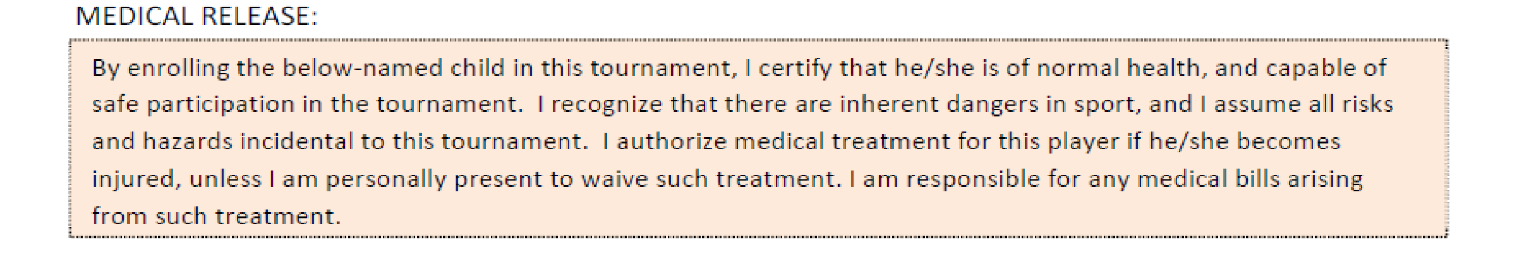
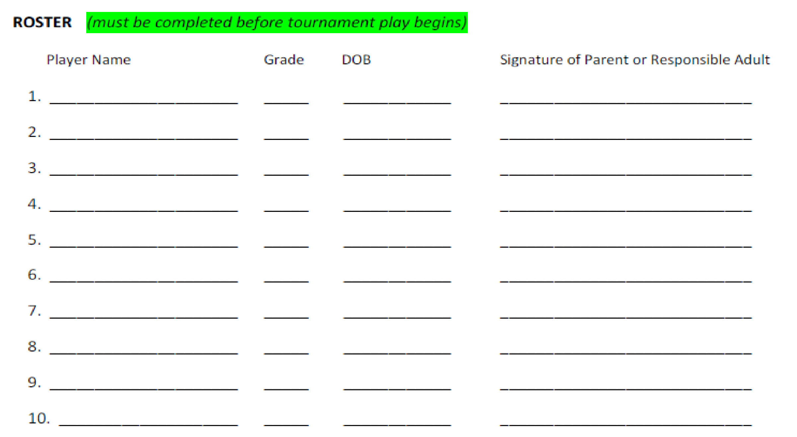
U10 U11 U12 U13 U14 U15 (circle one)

Payment Information
If you would like to reserve a space for your team, please call Megan Inman at 315-576-1461 or e-mail banditsvolunteers@gmail.com as soon as possible.
Please include club name, age group, and gender on all payments!

COMPLETED ROSTERS AND PAYMENT DUE BY FEBRUARY 17, 2023!!

To pay by CHECK:
Payable to Gananda Bandits Soccer Club Inc

Mail to: Gananda Bandits Soccer
PO Box 126
Walworth, NY 14568

To pay via PayPal:
Direct link : https://www.paypal.com/donate/?hosted_button_id=9C72G4QFUH6FL

PayPal QR CODE:

